**Chapter 5**

**DETAILED DESIGN**

**5.1 High level design**

High level design explains the architecture that would be used for developing software product. The architecture diagram provides an overview of an entire system, identifying the main components that would be developed for the product and their interfaces.

**5.1.1 Architecture of IPython Notebook**

The notebook extends the console-based approach to interactive computing in a qualitatively new direction, providing a web-based application suitable for capturing the whole computation process: developing, documenting, and executing code, as well as communicating the results. The Jupyter notebook combines two components:

* **A web application**: a browser-based tool for interactive authoring of documents whichcombine explanatory text, mathematics, computations and their rich media output.
* **Notebook documents**: a representation of all content visible in the web application,including inputs and outputs of the computations, explanatory text, mathematics, images, and rich media representations of objects.

**5.1.1.1 The IPython kernel**

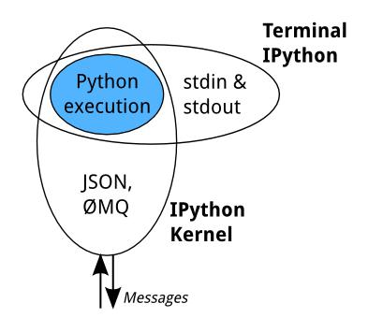

**Figure 5.1 Kernel Execution**

All the interfaces, like the Notebook, the Qt console, IPython console in the terminal, and third party interfaces use the IPython Kernel. The IPython Kernel is a separate process which is responsible for running user code, and things like computing possible completions. Frontends, like the notebook or the Qt console, communicate with the IPython Kernel using JSON

Department of CSE, RNSIT 2018-2019 20